**Article Title**

***Author1, Author2, and Author 3***

*Organization, http://www.organizationlink.xx*

**Abstract**: approximately 200 words, highlighting purpose, method, main issues discussed and key findings.

**Keywords**: 5-6 keywords or phrases.

### Introduction

In the last paragraph outlines the structure of the article.

### ?? Second Section Title

### ?? Third Section Title

### ?? Fourth Section Title

#### ?? Section Sub-title

#### ?? Section Sub-title

#### ?? Section Sub-title

### ?? Fifth Section Title

#### ?? Section Sub-title

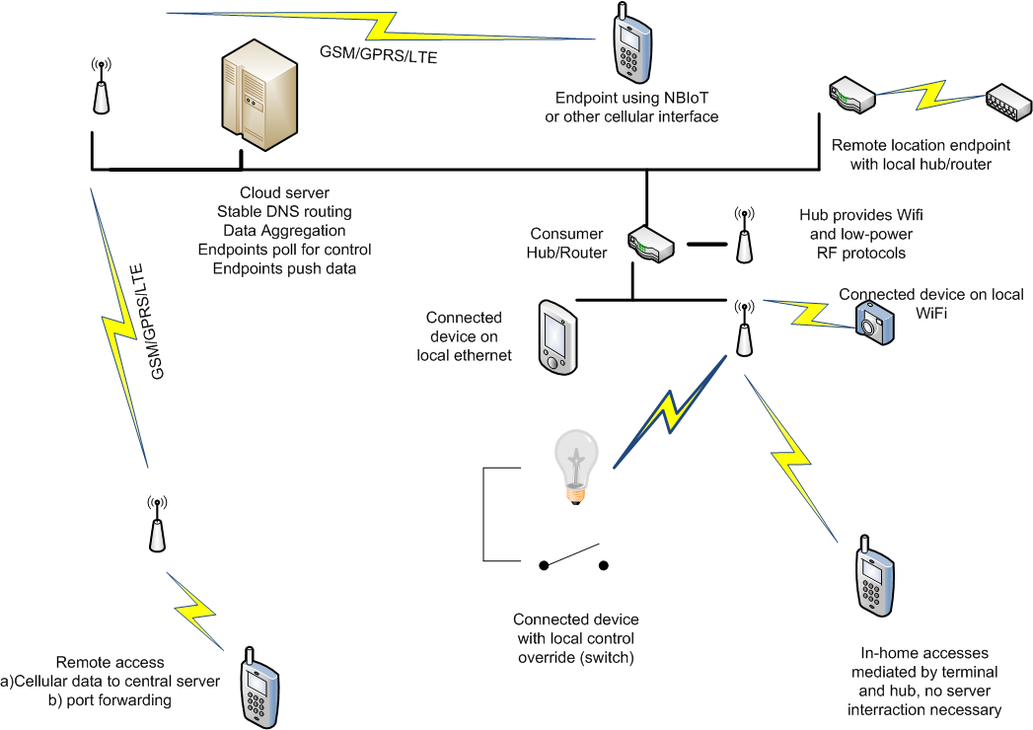

**Figure 1: Chart or Image of Print Quality.**

(Source: Business Insider, www.businessinsider.com).

#### ?? Section Sub-title

**Table 1. IoT Diffusion by Sector in Billions of Devices (2015–2020).**

|  |  |  |  |
| --- | --- | --- | --- |
| Category | 2015 | 2020 | Percent Increase |
| Automotive | 372 | 3511 | 944 % |
| Consumer | 2,875 | 13,173 | 458 % |
| Generic business | 624 | 5,159 | 827 % |
| Vertical business | 1,009 | 3,164 | 314 % |
| Total | **4,880** | **25,007** | **512 %** |

Source: Gartner, “4.9 Billion Connected ‘Things’ will be in use in 2015, November 2014.

#### ?? Section Sub-title

#### ?? Section Sub-title

#### ?? Section Sub-title

### Conclusion

### About the Authors

**Author 1 names** is …. 5-6 lines of text

*E-mail*:

ORCID: https://orcid.org/...

**Author 2 names** is ….

*E-mail*:

ORCID: https://orcid.org/...

**Author 3 names** is ….

*E-mail*:

ORCID: https://orcid.org/...

### Bibliography